Experiment Details

|  |  |
| --- | --- |
| Department Name | Production Engineering |
| Class | FY BTech. |
| Semester | 1st |
| Subject Name | Product Design and Development |
| Experiment No. | 1 |
| Experiment Name | 3 D Printing using FDM |

Version History

|  |  |  |  |  |
| --- | --- | --- | --- | --- |
| Sr. No. | Version Number | Created By | Approved By | Date |
| 1 | v1.0 |  |  |  |
|  |  |  |  |  |

AIM:

To print The Prototype Part using FDM based Printer

THEORY:

* In FDM CAD files must be translated into a file type, that 3D printing machines can understand.
* Standard Tessellation Language (STL) is one such file type and is the language most commonly used for stereolithography,
* The file is digitally sliced into a series of parallel horizontal cross--‐sections which are then provided to a FDM one at a time.
* Since additive manufacturing works by adding one layer of material on top of another, CAD models must be broken up into layers before being printed in three dimensions.
* FDM is the second most widely used rapid prototyping technology, after stereolithography.
* In Fused Deposition Modelling (FDM) process a temperature-controlled head extrudes thermoplastic material layer by layer.
* The FDM process starts with importing an STL file of a model into a pre-processing software. This model is mathematically sliced into horizontal layers varying from +/- 0.127 - 0.254 mm thickness. After generating the toolpaths, the data is downloaded to the FDM machine.

DISCRIPTION OF APPARATUS AND PROCESS:

* As the nozzle is moved over the table in the required geometry, it deposits a thin bead of extruded plastic to form each layer.
* The plastic hardens immediately after being discharged from the nozzle and bonds to the layer below.
* The object is built on a mechanical stage which moves vertically downward layer by layer as the part is formed.
* The entire system is contained within a chamber which is held at a temperature just below the melting point of the plastic.

DIAGRAM:

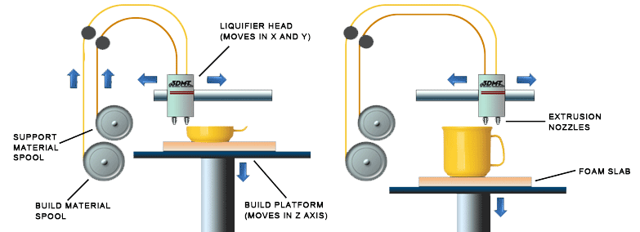

PROCEDURE: The heated nozzle and bed is heated to prerequired temperature. Th filament is passed through the nozzle hole and the program is executed.

Advantages:

* FDM Models are Strong and Durable.
* Models are Stable and never warp / shrink
* Models can go through milling, tapping and boring operations
* Models can be sanded, painted and finished as required
* Large Models can be built in multiple sections and joined with ease and accuracy
* Models are non toxic and safe to handle
* ABS material can be used
* Multiple material colors can be obtained

Limitations:

* Process is comparatively slower for larger parts.
* Support structures are required (sometimes may require more support material than the part itself).
* The finished parts are anisotropic, that is they exhibit different mechanical characteristics in different directions

Applications:

* The resolution is not as fine as with stereolithography
* Prototypes for functional testing; you can install and run the parts in your production intent material for the best possible proof that your design really works
* Prototypes for form and fit testing
* Prototypes directly constructed in production materials
* Quality parts with a high structural stability
* Durable single piece parts up to 900 x 600 x 900 mm

REFERENCES:

Write names of text books and reference books for experiment.